# Testing the creation of objects from class TVProgram

In this assignment, player.py is used to pass parameters to the class in tvprogram.py, to create objects to store TV shows details.

For this to work, we need to send the following details:

Tv show title – string

Episode title – string

Season number – integer

Episode number – integer

Description – string

Genre – string

Rating – integer

Duration – integer

Web url – string

Image url – string

Video url – string

Director – string

Actors – array

## Test 1: creating 3 objects

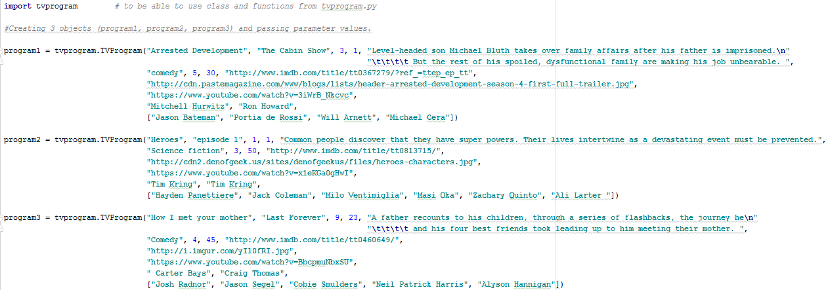

Figure : creating 3 objects from player.py

Since no error was returned by the console, all values were passed on effectively to tvprogram.py

## Executing player.py

Object 1: program1

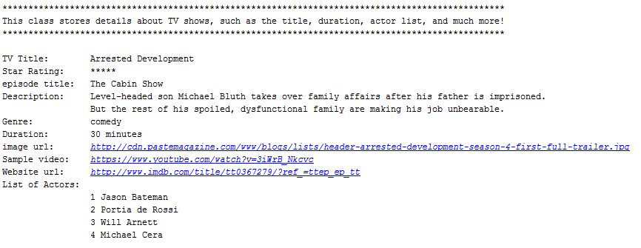

Figure : on-screen display of program1



Figure :Opening website for program1

Object 2: program2

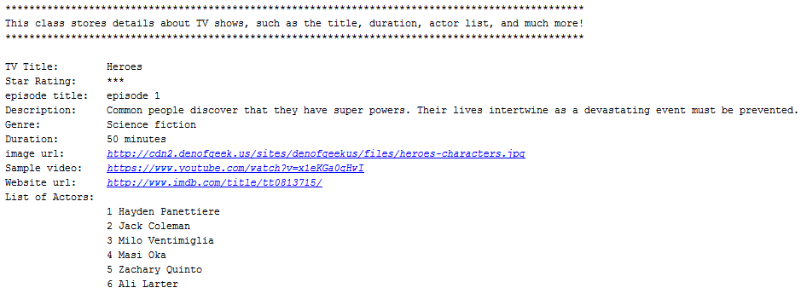

Figure : on-screen display of program2

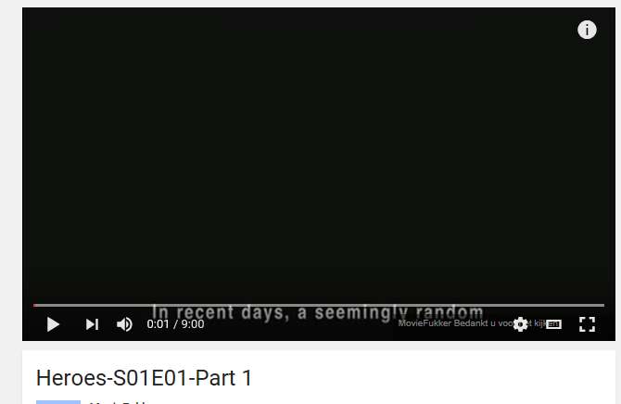

Figure : opening video url for program2

Object 3: program3

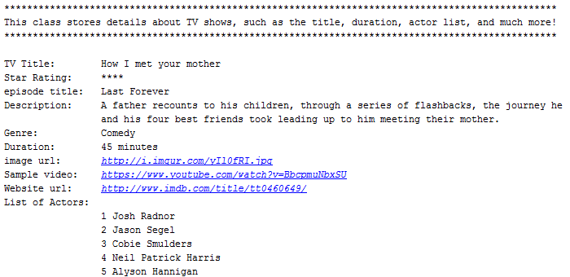

Figure : on-screen display of program3



Figure :opening image url for program3